# 4 Design Chapter

This chapter will focus on what is important to consider in the design process. The system architecture, UI (User Interface),

## 4.1 System Architecture

### User Flow

When designing a game, the developer must think about how the user will move through the application. The developer must understand what the user will find irritating but also what the user will like and appreciate.

(User flow diagram here)

## 4.2 User Interface Design

(Explain what I want to have my UI like with sketch and why I want it like that.)

### 4.2.1 Inspiration

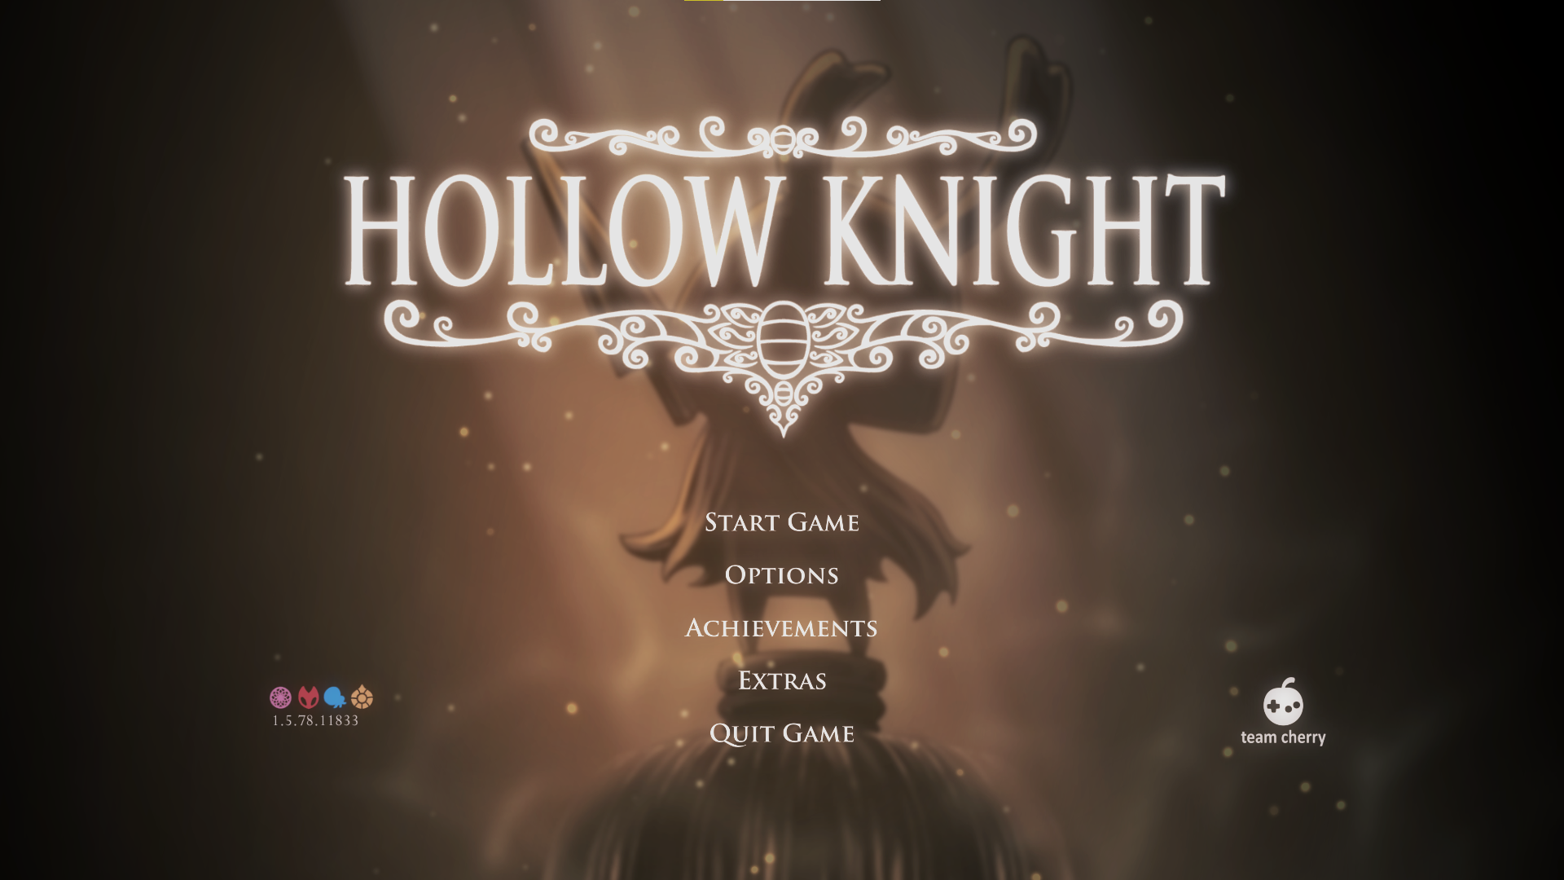

Figure : Screenshot taken by the author showing the Menu UI

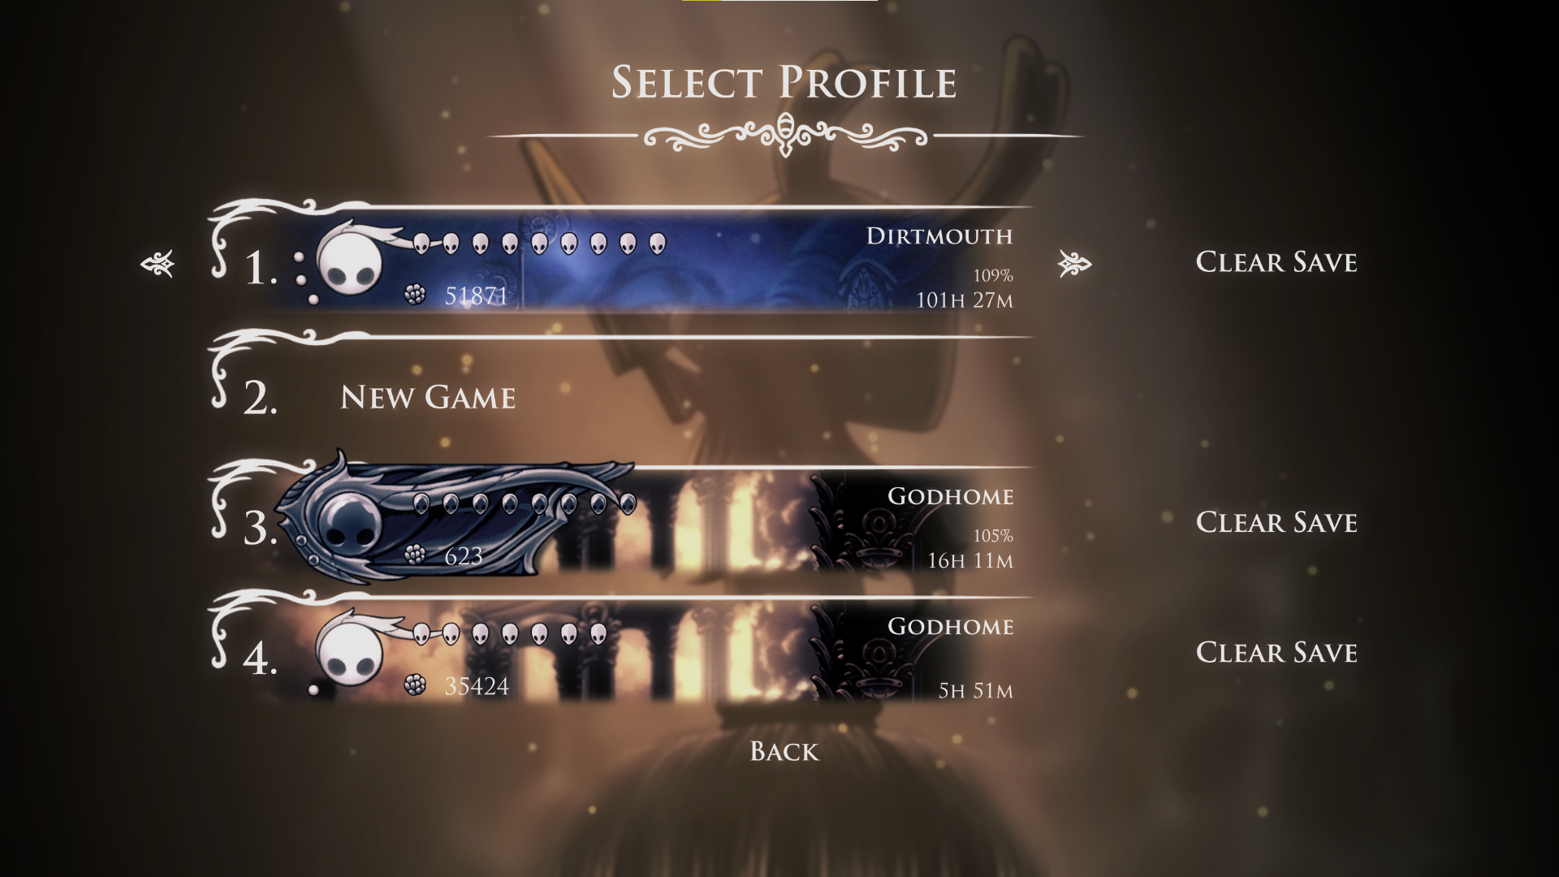

Figure : Screenshot taken by the author showing the save files

In **Figure 3** we can see that there are different layers to even a 2D game, this adds depth to a game where you can only move up down left and right as seen in **Figure 3** The background labelled **A** is the furthest back and will appear behind all other objects in the game. While the background labelled **B** is on top of **A** and will appear on top of that, the area labelled **C** is the plane that the player is on and can explore. The layer Labelled **D** is in front of the player Level and the player will be hidden behind objects that are on this layer. There is also a layer in front of **D** that is used occasionally.

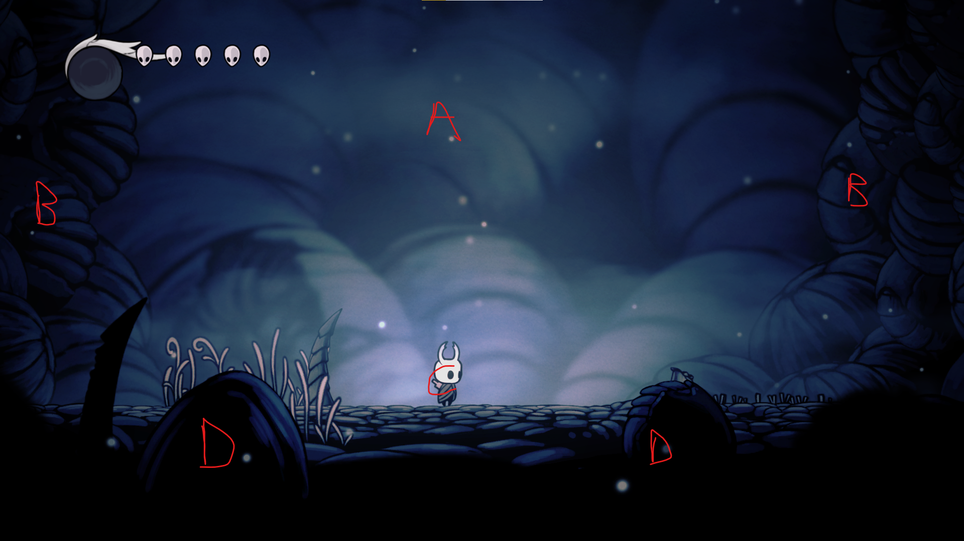

Figure : Screenshot taken by the author showing an example of how layers are used in Hollow Knight

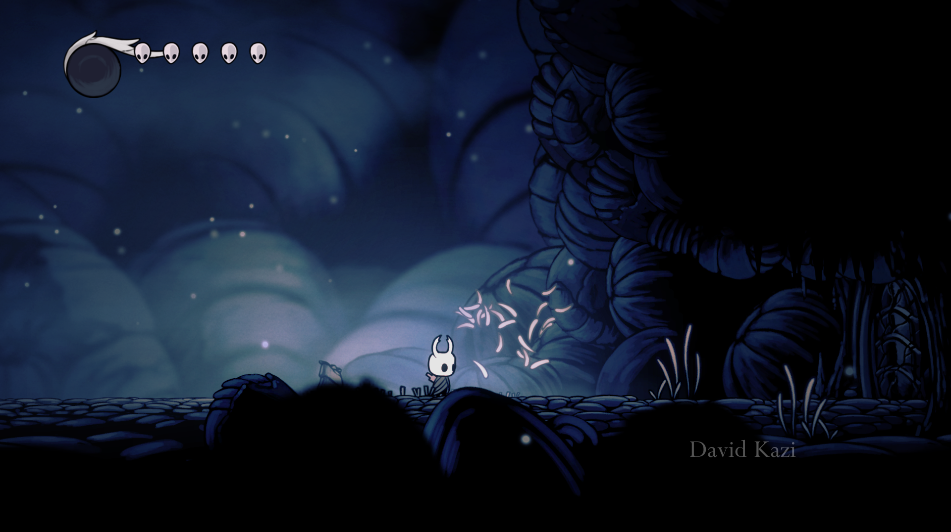 Figure : Showing interactable environment from Hollow Knight

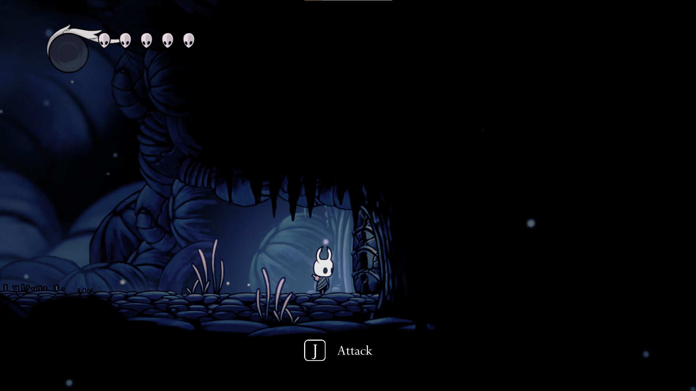

Figure : Showing interactable environment from Hollow Knight

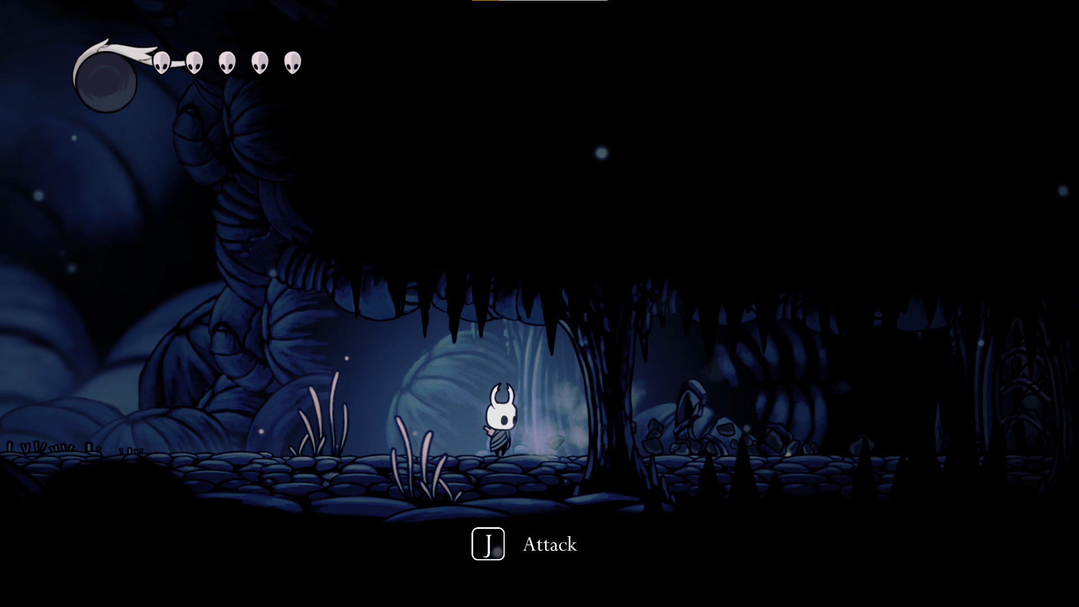

Figure : Showing interactable environment from Hollow Knight

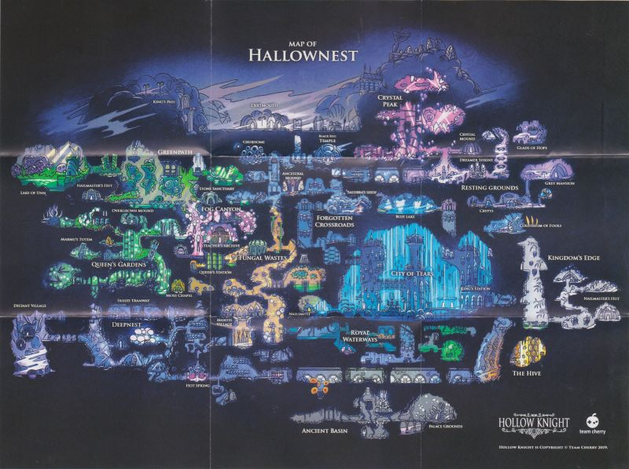

Figure : Full map of every area in Hollow Knight

## 4.3 Proposed Map Layout

(Sketch of the game map maybe a higher fidelity map drawn up in photoshop.)